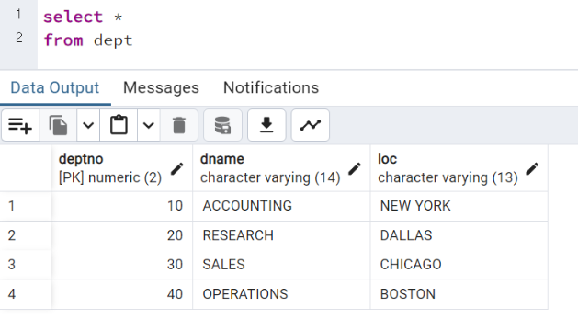
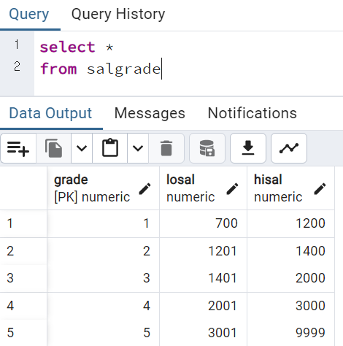

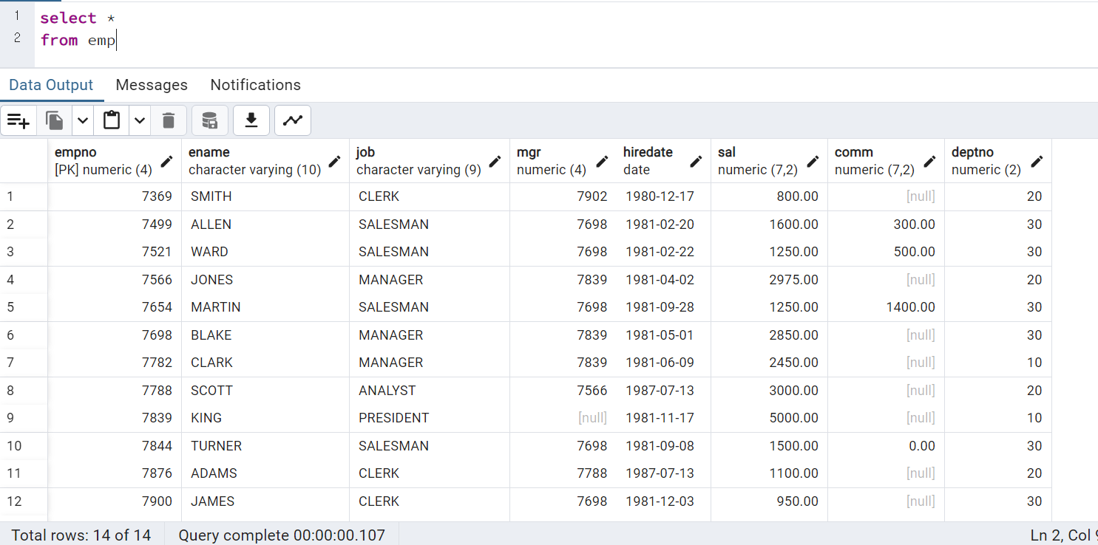

select empno,ename, hiredate
from emp
order by hiredate asc

select ename, sal, sal*12 as "연봉"
from emp
order by 연봉 desc

select ename, deptno
from emp
where deptno >= 10 and deptno <= 20
order by ename

select ename, sal, comm
from emp
order by comm desc

select ename
from emp
where ename like '__A%'

select INTICAP(ename) as ename, length(ename) as nlength
from emp
where ename like 'A%' or ename like 'J%'
or ename like 'M%';

select count(*)
from emp
where deptno=30;

select job, max(sal)
from emp
group by job

select sum(sal)
from emp
where deptno=20;
select deptno, sum(sal) as sal
from emp
group by deptno
having sum(sal)>=7000;

select job, ename, max(empno)
from emp
group by job
having empno = like '79%'

select job, sum(sal) as sal
from emp
where job<> 'MANAGER'
group by job
having sum(sal)>5000

select d.loc, count(e.empno) as empno
from dept.d
left join emp.e on d.deptno=e.deptno
group by d.loc
having count(d.loc)<=5
order by count(e.empno),d.loc;

SELECT e.ename AS employee, e.empno AS emp, m.ename AS manager, m.empno AS mgr
FROM emp e
LEFT JOIN emp m ON e.mgr = m.empno
WHERE m.empno IS NULL OR m.empno = (SELECT empno FROM emp WHERE ename = 'King')
ORDER BY e.empno;

